Grade 7 Accelerated · Unit 4 · Lesson 6  Order of Operations with Radicals  Question Bank - Additional 4.06 | Name______________________  Date______________________  Period____________________

Show your work. Circle your final answer.
For questions 1 through 6, evaluate.
1. 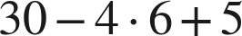

2. 

3. 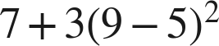

4. 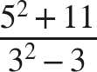

5. 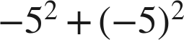

6. 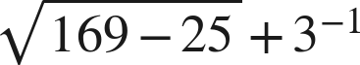

For questions 7 and 8, evaluate. Each expression has more than one grouping symbol.
7. Evaluate each expression.
a. 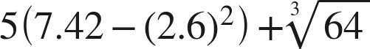

b. 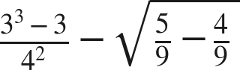

c. 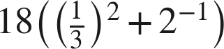

8. Evaluate each expression.
a. 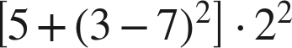

b. 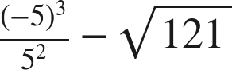

c. 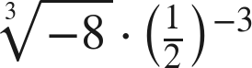

Working backwards.
9. Find the value of that makes each statement true.
a. 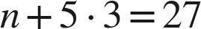

b. 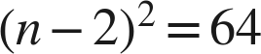, where is greater than 2

c. 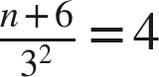

Reading someone else's work.
10. Liesel says that , because addition comes before subtraction. Is she right? Explain, and give the correct value.

11. Which is the value of 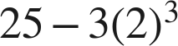 ?
○ A. 1
○ B. 216
○ C. 484
○ D. 7

12. Select ALL of the expressions whose value is 9.
□ A. 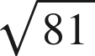
□ B. 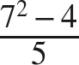
□ C. 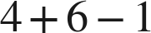
□ D. 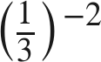
□ E. 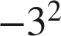
□ F. 

